India tour 14-30 November 2018
Hotels day 11
Days 11 - Pushkar, located North East of Udaipur some 278klm in semi-desert region of Rajasthan.
Saturday 24th November 2018 at the Hotel Taj Gateway. Address Jaipur Village Hokra, Pushkar Road, Ajmer, Rajasthan.
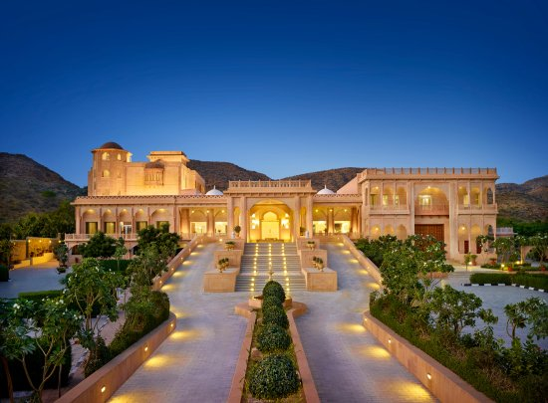
Grand view of Taj Gateway hotel in Pushkar as provided by the hotel web-site.
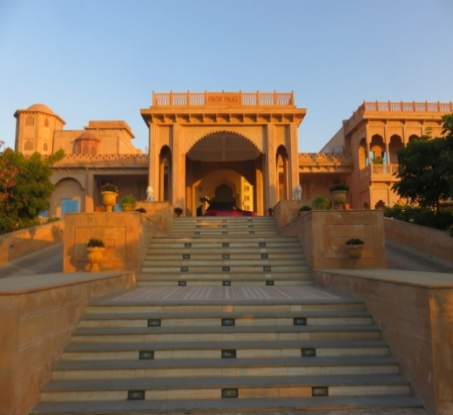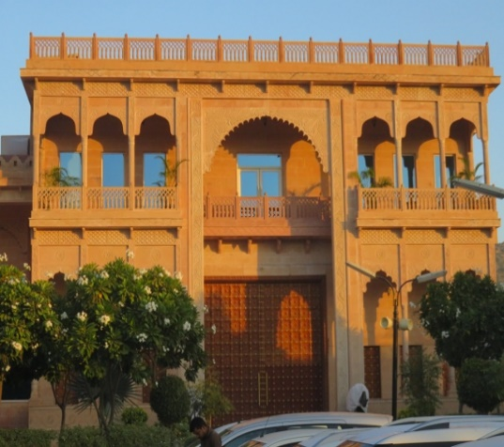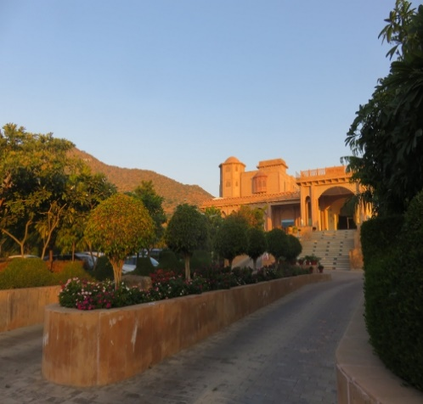
Close up of those stairs to lobby grand gate to hotel from inside view of gardens leading up to lobby.
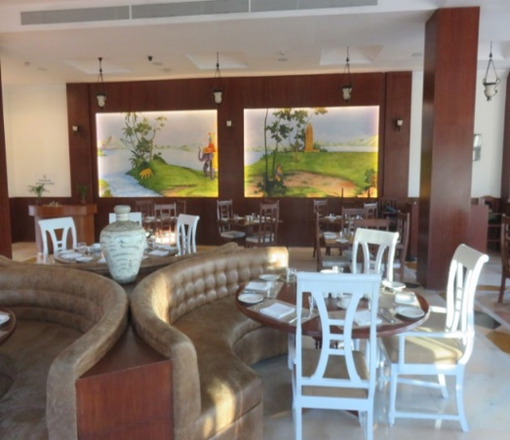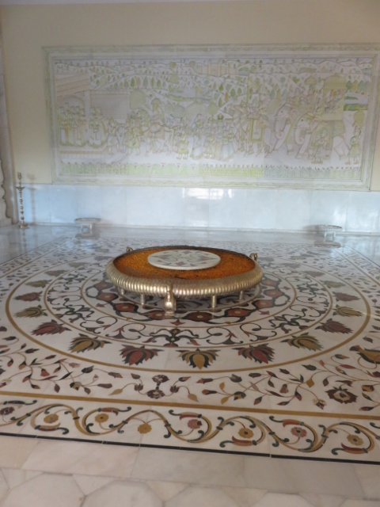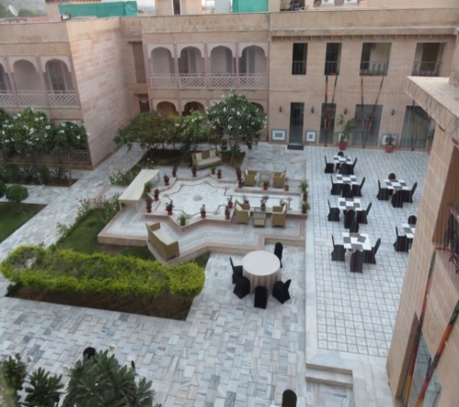
Inside dining area round table in lobby area outside dining area.
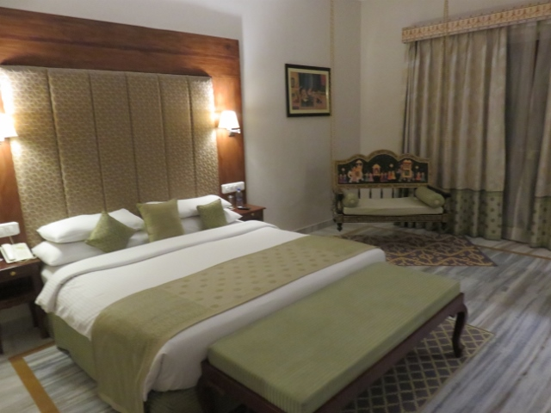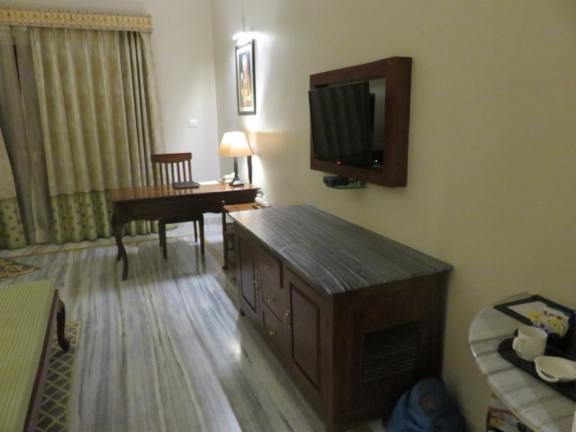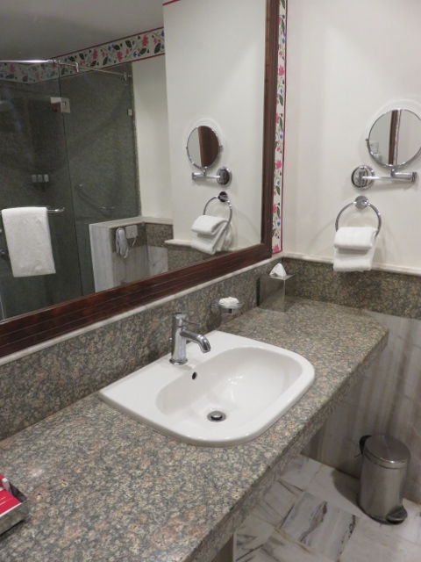
Alan’s room 3006- note chair other side of room bathroom.
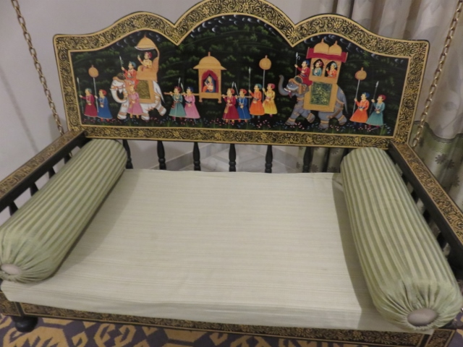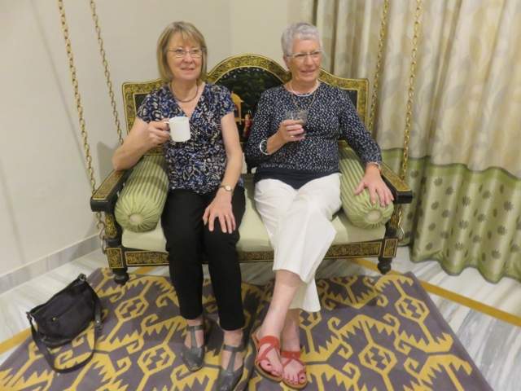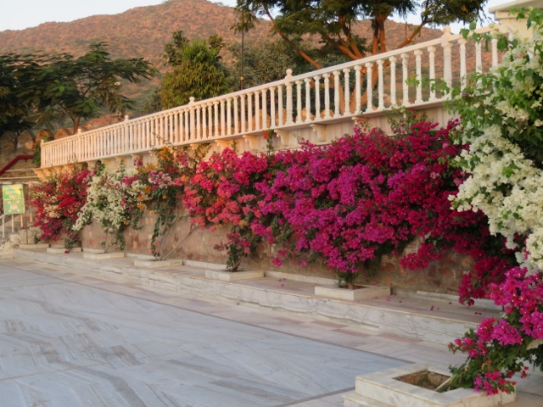
Suspended chair held up by chains to ceiling. Ros and Kerrie in for a cuppa. Bougainvillea at rear of hotel complex.
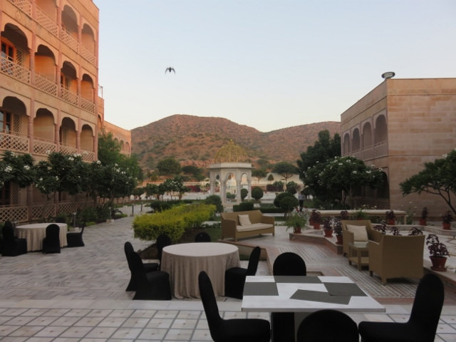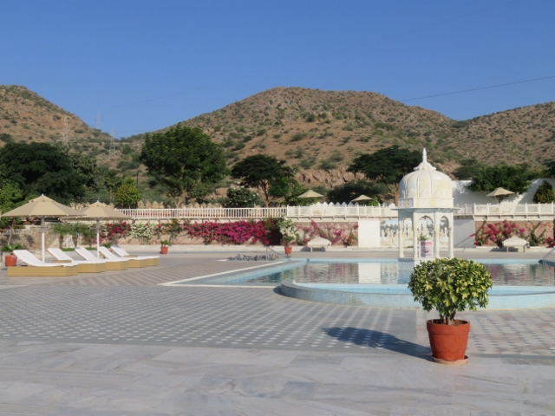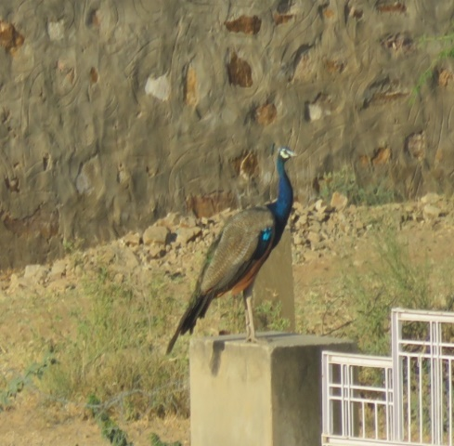
Looking towards swimming pool swimming pool and back gardens wild peacock on next door wall.

Pushkar as a city is favoured as a religious centre by the Hindu people. The centre of the city has a rectangular lake with many temples built around each side. Unfortunately no photographs are allowed inside as well as having to remove any shoes and socks. A challenge to walk around the steep sloping steps on the inside of the complex.
As a result of Pushkar’s religious significance, no alcohol could be purchased in the area and thus not allowed at meals. The usual buffet style meals for dinner and breakfast was on offer with the group beginning to discern between what was scalding hot chilli dishes and what was OK.
The grand name of the Taj Gateway Hotel is no doubt used as an attraction for tourises (us included), however the hotel could best described as 4.5 star. A bit of a down sizing from the previous couple of days.

